Analysis

1.Churn rate-
We found the churn rate was 26.5%, meaning we are losing 2.2% of customers per month.

Cause of churn rate-
A.Contract Type-
Churn rate as per contracts was found to be-

Our overall churn is 26.5% but it is driven almost entirely by month-to-month contract users

Cause of high churn rate for month to month-
Month-to-month users on average pay the highest among all.
This could be the leading factor causing high churn rate contributed by month-to-month users
Churned users pay $13.17 more than those who stayed irrespective of contract type. That is a 21.5% price gap!

Conclude-
contract-month-to-month are primary churns
price-those paying $13+ more are likely to leave
time-users with high tenure are less likely to be affected by high prices than those who have been with us for less than 1 year.

Solution-
- Crucial first year-we need a retention program specifically for customers in their first 12-18 months.
- Price bridge-since high bill is killing retention. Offering a loyalty discount ,to switch from month-to-month to 1 year contract, at month 12 could save thousands of revenue.

B.Internet Service-

Internet Service | Churn Rate
DSL | 19.0%
Fiber optic | 41.9%
No | 7.4%

Conclusion-
We notice that fiber optics have the highest churn rate (41.9%)

Solution-
- provide immediate expert help especially to new users who have installation issues.
- provide service bundles for fiber users like giving device protection, tech support and online security. This will make the high costs justified.
- Fiber users operate on month to month and leave easily ,encourage 1-2 years plan by providing loyalty discounts.

C.Payment Method-

Conclusion-
We notice electronic check has the highest churn rate (45.3%) compared to other payment methods.

Solution-
- company can provide small discounts of about $2 for switching to auto pay to lock in the customers.
- use automated email, SMS or in-app notifications to prompt customers to update payment details before they expire.
- provide a grace period of 7-14 days after the failed payment where the service continues, to let the customer have time to fix the issue.

D.Services-

Number Of Services | Churn Rate
0 | 21.4%
1 | 45.8%
2 | 35.8%
3 | 27.4%
4 | 22.3%
5 | 12.4%
6 | 5.3%

We summed up the number of services each customer had and compared their churn rates

Conclusion-
We notice those with higher services are less likely to leave

Solution-
- create bundles where 1 service includes another service for free.
- at the 12 month mark offer loyalty upgrade. Here we give a 3rd service for free for 3 months. By the time the 18th month churn window hits they are already dependent and used to the current services and find it profitable to invest more.

2. Service Stickiness-

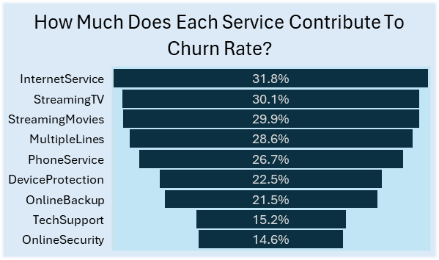
Conclude-
Our internet service users have the highest churn rate while those with online security and tech support have the lowest churn rate.

Solution-
This calls for further investigation into the quality of the internet services provided by the company and improving it or providing service combos where internet service bundles include online security and tech support.

